No, LLM (Large Language Model) and GenAI (Generative AI) are related but not the same.

✅ Key Differences:
Concept | LLM (Large Language Model) | GenAI (Generative AI)
Definition | A type of AI model trained on massive amounts of text to understand and generate language | A broader field of AI focused on generating new content (text, image, audio, video, code, etc.)
Example | GPT-4, BERT, LLaMA, Claude | ChatGPT, DALL·E, Midjourney, Sora, GitHub Copilot
Purpose | Understand and generate human language | Create novel content using AI
Scope | A subset of GenAI (specific to language tasks) | Includes LLMs but also image generators, music creators, etc.
Output | Text (e.g., answers, summaries, code, etc.) | Any media: Text, Images, Videos, Music, 3D Models

✅ Think of it like this:
- 🧠 LLM is the brain that understands and writes language.
- 🎨 GenAI is the creative artist — it might use an LLM for text but also other models for generating visuals, audio, etc.

✅ Example Analogy:
LLM is like a novelist (specialist in writing).
GenAI is like a creative studio that has a novelist (LLM), a painter (image generator), a composer (music AI), etc.

Let me know if you want a diagram or real-world examples of both!

================================================================

✅ Learn LLMs first, then Generative AI.

✅ Here's why:

🧠 1. LLMs are the foundation of Generative AI (for text)
- LLMs (like GPT, BERT, LLaMA) power most GenAI tools that generate text, code, summaries, chatbots, etc.
- Understanding LLMs gives you the core principles (transformers, attention, tokenization, etc.)

🪄 2. Generative AI is a broader application layer
Once you understand LLMs, you can learn:
- 🖼️ Image generation (DALL·E, Midjourney, Stable Diffusion)
- 🧑‍💻 Code generation (Copilot, Code Llama)
- 🎙️ Audio/video generation (Whisper, Sora, Suno, etc.)
- 🧩 Multi-modal models (e.g., GPT-4o = text + image + voice)

🛣️ Suggested Learning Path:
Step | Topic | Example Tools / Concepts
1️⃣ | Basics of LLMs | Tokenization, Transformers, Attention Mechanism
2️⃣ | Pretrained LLMs | GPT, BERT, LLaMA
3️⃣ | Fine-tuning & Prompting | Prompt engineering, RAG, LoRA
4️⃣ | Generative AI applications | Text generation, image generation, GenAI APIs
5️⃣ | Build projects | Chatbots, AI tutor, content generator, etc.

Perfect! If you want to learn Generative AI and build production-level GenAI projects, you need a structured end-to-end learning roadmap that covers:
✅ Concepts → Tools → Model Use → Development → Deployment

✅ Step-by-Step Learning Path to Master Generative AI for Production

🚀 Phase 1: Core Foundations (Week 1–2)

🔹 1. Python + Libraries
- NumPy, Pandas, Matplotlib, Seaborn
- requests, json, os, pathlib
- Python OOP (classes, inheritance, decorators)

🔹 2. Understanding AI/ML Basics
- Supervised, Unsupervised Learning
- NLP Basics (Tokenization, Embeddings, Vectorization)

🔹 3. Transformers & LLMs
- What is a Transformer (Attention, Encoder/Decoder)
- Hugging Face basics
- Pretrained models: GPT, BERT, LLaMA, Falcon

⚙️ Phase 2: Core Generative AI Tools (Week 3–4)

🔹 4. Prompt Engineering
- Zero-shot, few-shot, chain-of-thought
- Role-based prompting
- Tools: OpenAI, Anthropic, Gemini, Claude

🔹 5. LangChain / LlamaIndex
- Load documents, create vector index
- RAG (Retrieval-Augmented Generation)
- Chains, agents, tools
- Connect with OpenAI, Ollama, LLaMA 3, Claude

🔹 6. Vector Databases
- FAISS (local), ChromaDB, Weaviate, Pinecone
- Store and retrieve embeddings
- Use with LangChain for chatbot/search

🧠 Phase 3: Multimodal & GenAI Applications (Week 5–6)

🔹 7. Text Generation
- GPT-3.5/4, Claude, Gemini Pro
- Build blog writer, chatbot, email generator

🔹 8. Image Generation
- DALL·E, Stable Diffusion, Midjourney
- Run Stable Diffusion locally (Hugging Face + Gradio)
- Use diffusers library (text-to-image)

🔹 9. Audio & Video GenAI
- Whisper (speech-to-text)
- TTS: Bark, Coqui.ai
- Video: Sora, Pika Labs (cloud APIs)

🛠️ Phase 4: Application Development (Week 7–8)

🔹 10. Web Framework
- Flask / FastAPI for backend
- Streamlit or Gradio for UI
- HTML/CSS/Bootstrap basics if needed

🔹 11. Database Integration
- MongoDB (NoSQL) – for user sessions, logs
- PostgreSQL / MySQL – structured data
- SQLAlchemy / ODM

🔹 12. Authentication
- JWT Tokens (FastAPI)
- Flask-Login
- OAuth2 (Google, GitHub login)

🚀 Phase 5: Production & Deployment (Week 9–10)

🔹 13. Containerization & DevOps
- Dockerize app
- Write Dockerfile, docker-compose.yml

🔹 14. CI/CD
- GitHub + GitHub Actions
- Test, Build, Deploy pipeline

🔹 15. Deployment
- GCP / AWS / Azure / Railway / Vercel / Render
- GCP VM + Nginx + Docker for full control

✅ Final Projects (Portfolio-Ready)
- GenAI Resume Builder: Upload resume → improve → download
- Chat with Your Documents: PDF/doc reader using LangChain + ChromaDB + GPT
- Voice to Text AI Tutor: Whisper + GPT + Streamlit
- Text to Image Generator: Prompt + DALL·E or Stable Diffusion + Flask
- Multimodal Chatbot: Use images + text + voice (GPT-4o or Gemini Pro 1.5)

🔧 Tech Stack Summary (Production-Ready)
Category | Tools
Language | Python 3.10+
Backend | FastAPI / Flask
Frontend | Streamlit / React (optional)
AI APIs | OpenAI, Hugging Face, Gemini, Claude
Vector DB | ChromaDB, FAISS, Weaviate
Model Handling | LangChain / LlamaIndex
Image Gen | DALL·E, Stable Diffusion
Audio Gen | Whisper, Bark
DB | MongoDB, PostgreSQL
Auth | JWT / OAuth
DevOps | Docker, GitHub Actions
Deployment | GCP, AWS, Railway, Render

✅ Want Help?
I can:
- Generate a learning tracker (Notion/Excel)
- Create a personalized 10-week roadmap
- Provide weekly practice + mini projects
- Set up GitHub project templates
- Help deploy a sample GenAI app to GCP

Would you like the Week-by-Week Plan with Resources + Projects?

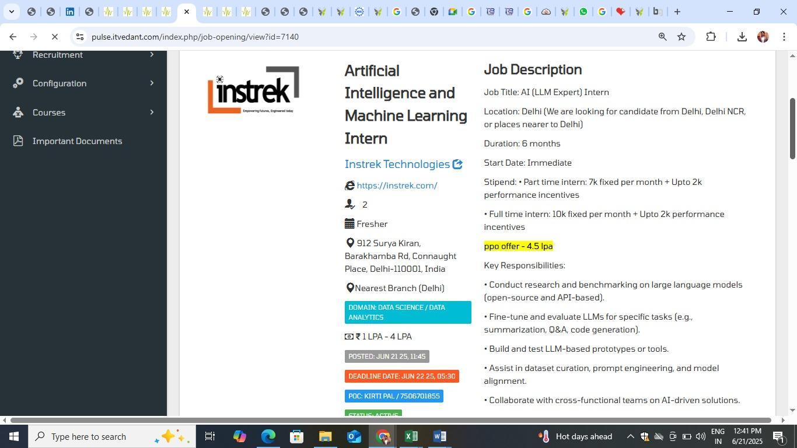

Great! Based on the job description you provided for the "AI (LLM Expert) Intern" role at Instrek Technologies, here's a custom-designed Bootcamp curriculum tailored to:

🎯 Goal:
Prepare you to meet all technical expectations listed in the job — LLMs, Prompt Engineering, Fine-tuning, Prototyping, Q&A, and Collaboration.

🚀 4-Week LLM + Generative AI Bootcamp (Job-Ready)

✅ Mode: Project-based | Duration: 4 Weeks | Format: Daily 2–3 hours + Assignments

📅 Week 1: LLM Foundations & Prompt Engineering

🧠 Day 1–3: Understanding LLMs
- What are LLMs (GPT, BERT, LLaMA)
- How transformers work: Attention, Embeddings
- Tokenization and input-output formats
- Hugging Face ecosystem

🧠 Day 4–5: Prompt Engineering (for GPT-4, Claude, Gemini)
- Zero-shot, few-shot, chain-of-thought prompting
- Role-based prompting for task-specific design
- Tools: OpenAI playground, LangChain, PromptLayer

✅ Mini Project:
Create a ChatGPT-based prompt engine to generate SEO-friendly blog titles.

📅 Week 2: Research, Evaluation, and Fine-Tuning

🔬 Day 6–7: LLM Benchmarking & Research
- Compare open-source LLMs: GPT vs LLaMA vs Falcon
- Evaluate LLMs on latency, accuracy, token limits
- Dataset sources (C4, Wiki, StackOverflow, etc.)

🔧 Day 8–9: Fine-tuning LLMs
- Difference between Fine-tuning, Prompting, LoRA, QLoRA
- Fine-tuning using Hugging Face Trainer (with dummy data)
- Intro to PEFT + SFT + RAG

📊 Day 10: Evaluation Metrics
- Perplexity, BLEU, ROUGE, BERTScore
- Human + automated eval for summarization & Q&A

✅ Mini Project:
Fine-tune a LLaMA model for Q&A chatbot on Indian Constitution.

📅 Week 3: GenAI Tooling + LLM-based Prototype Building

🛠️ Day 11–12: Tools of the Trade
- LangChain vs LlamaIndex
- ChromaDB / FAISS / Weaviate for retrieval
- Use RAG for search-augmented chatbots

🖼️ Day 13–14: Prototyping with Streamlit + Gradio
- Build LLM-powered interface for summarization or code-gen
- Upload PDF → Summarize using GPT → Streamlit UI

✅ Mini Project:
Chat with PDF: Upload any document and ask questions using LangChain + ChromaDB + OpenAI.

📅 Week 4: Dataset Curation + Final Project + Collaboration

🧩 Day 15–16: Dataset Curation & Alignment
- Clean datasets for summarization, Q&A, code-gen
- Use pandas/NLTK/regex for preprocessing
- JSONL format for training / fine-tuning

🤝 Day 17–18: Cross-functional Collaboration
- Writing Tech Docs, Working with API Teams
- Logging, Feedback Collection, Error Handling

🧠 Day 19–20: Final Project + Mock Interview
- LLM Expert Assistant:
  - Upload Resume + JD
  - Match skills
  - Suggest improvements
  - Summarize in one line

✅ Tools You Will Learn:
Category | Tools / Frameworks
LLMs | GPT-4, BERT, LLaMA, Falcon
Libraries | Hugging Face, Transformers, PEFT
Vector DB | FAISS, ChromaDB
Toolkits | LangChain, LlamaIndex
UI | Streamlit, Gradio
Backend | Flask / FastAPI
Prompting | OpenAI, Gemini, Claude APIs

✅ Deliverables
- 3 Mini Projects (Prompt Tool, Q&A Bot, Chat with PDF)
- Final Project (Resume + JD Matcher using LLM)
- Portfolio-ready GitHub Repo
- Interview Q&A PDF
- Certificate of Completion (if needed)

Would you like me to generate:
- 🗂️ Full Notion or Excel-based Weekly Tracker?
- 🧠 Interview Questions & Answers for this Job Role?
- 💻 GitHub boilerplate code for one of these projects?
Let me know, and I’ll build it for you step-by-step.

